**AI Based Discourse for Banking Industry**

|  |  |
| --- | --- |
| Date | 25 October 2022 |
| Team ID | PNT2022TMID15846 |
| Project Name | AI Based discourse for Banking Industry |
| Team Members | Sneha M  Swetha K  Yuvanthika S  Shree Lakshmi R |

**SPRINT-I**

Create IBM service

1.Create IBM Watson Assistant Service.

2.Create or enrol into IBM cloud for deployment of the application.

**CREATION OF IBM WATSON ASSISTANT SERVICE:**

1.Click on the catalog and you will be redirected to a page that will show you all the IBM services, from your left pane click on AI and then select Watson Assistant.

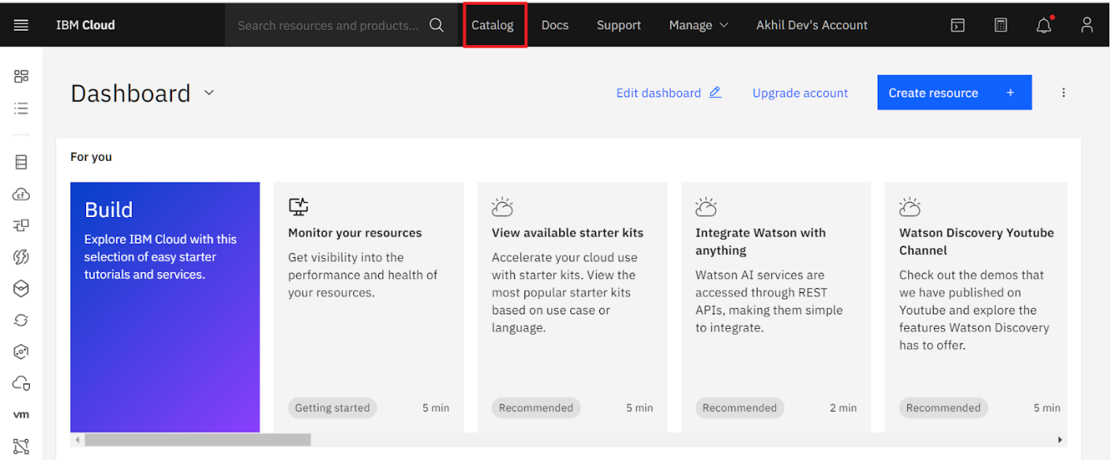

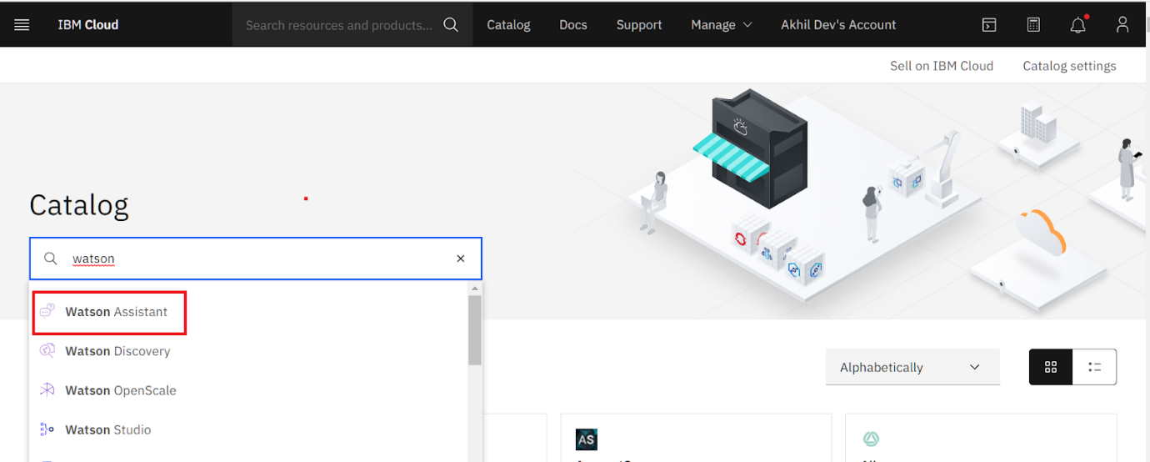

1. Ensure that “Dallas” is selected as a region click on create.

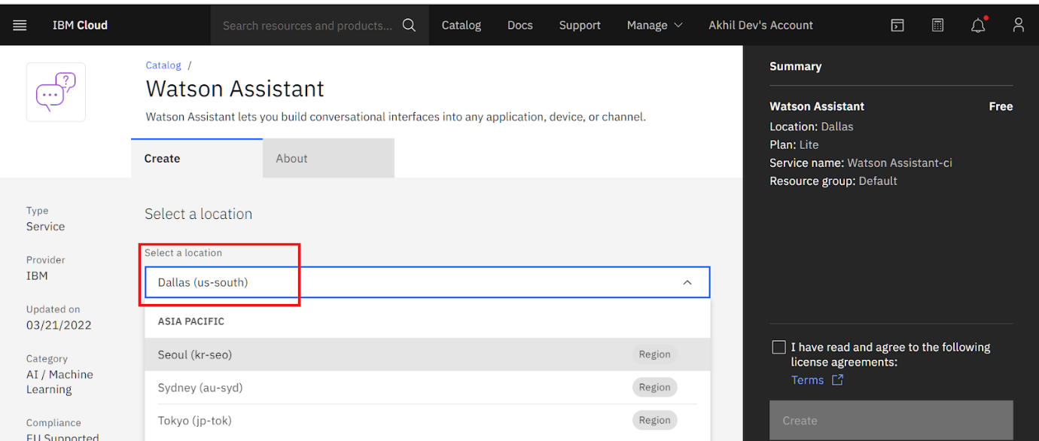

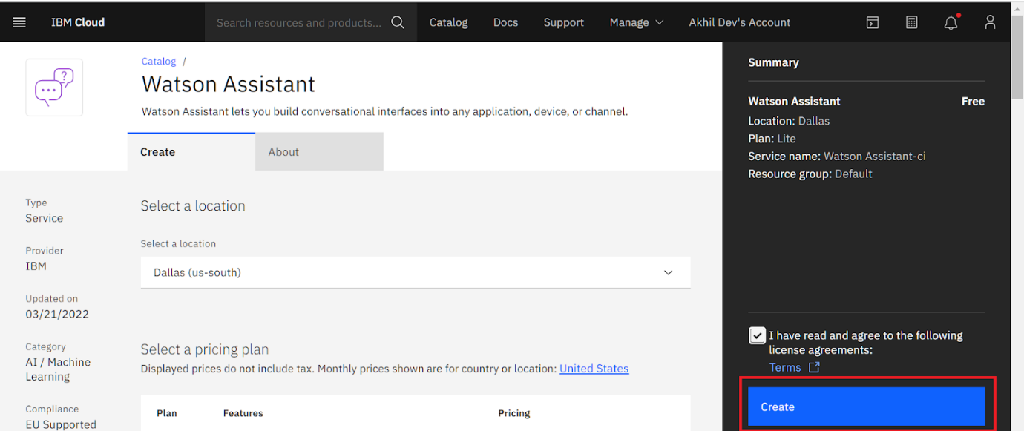

3.Upon successful login to the cloud, you will be on the "Watson Assistant" page. Click on Launch Watson Assistant.

